PHASE 2 BIG DATA ANALYSIS WITH IBM CLOUD DATABASES

**INTRODUCTION:**

Big data analysis involves the process of collecting, processing, and analyzing vast volumes of data to extract valuable insights, patterns, trends, and information. It is a critical component of decision-making and problem-solving in various industries and domains. Here is a step-by-step overview of the big data analysis process.

**BIG DATA ANALYSIS:**

1. **Data Collection:**
   * The first step is to gather and collect data from various sources, which can include structured data (e.g., databases, spreadsheets) and unstructured data (e.g., text, images, social media feeds). Sources may also include IoT devices, sensors, and external data providers.
2. **Data Ingestion:**
   * Once collected, data needs to be ingested into a central repository or data storage system. Common options include data lakes, data warehouses, and distributed file systems like Hadoop HDFS.
3. **Data Preprocessing:**
   * Raw data is often messy and requires preprocessing. This step involves cleaning, transforming, and structuring the data to make it suitable for analysis. It may also involve handling missing values and outliers.
4. **Data Storage:**
   * The processed data is stored in a format that facilitates efficient querying and analysis. Depending on the size and structure of the data, you may use relational databases, NoSQL databases, or distributed storage systems like Apache HBase or Amazon S3.
5. **Data Analysis:**
   * This is the core of the process. Various techniques and tools are used to analyze the data, including statistical analysis, machine learning algorithms, data mining, and natural language processing. The choice of analysis method depends on the goals of your analysis.
6. **Data Visualization:**
   * Once insights are extracted from the data, it's essential to present them visually through charts, graphs, dashboards, and reports. Visualization aids in better understanding and communication of findings.
7. **Advanced Analytics:**
   * For more complex analyses, you may apply advanced techniques like predictive modeling, clustering, classification, and sentiment analysis. Machine learning and deep learning models can be used to make predictions and recommendations.
8. **Interpretation and Insights:**
   * The analysis results are interpreted to derive meaningful insights and actionable recommendations. These insights can drive business decisions, inform strategies, or address specific research questions.
9. **Iteration:**
   * Big data analysis is often an iterative process. You may need to revisit previous steps, refine your analysis, or incorporate new data as the situation or objectives evolve.
10. **Deployment and Integration:**
    * If your analysis leads to actionable insights, you may need to deploy the results into production systems or integrate them into existing processes. This step ensures that the value from your analysis is realized.
11. **Data Security and Privacy:**
    * Throughout the entire process, it's crucial to maintain data security and privacy, especially when dealing with sensitive or personal information. Compliance with data protection regulations is essential.
12. **Scalability and Performance Optimization:**
    * As the volume of data grows, scalability and performance become critical considerations. Scaling infrastructure and optimizing algorithms are ongoing efforts.
13. **Monitoring and Maintenance:**
    * Continuously monitor the performance of your analysis systems, data quality, and the relevance of your models. Regular maintenance and updates are necessary to keep the analysis accurate and up-to-date.
14. **Documentation and Collaboration:**
    * Document your analysis processes and results thoroughly, and collaborate with team members to ensure knowledge sharing and reproducibility.

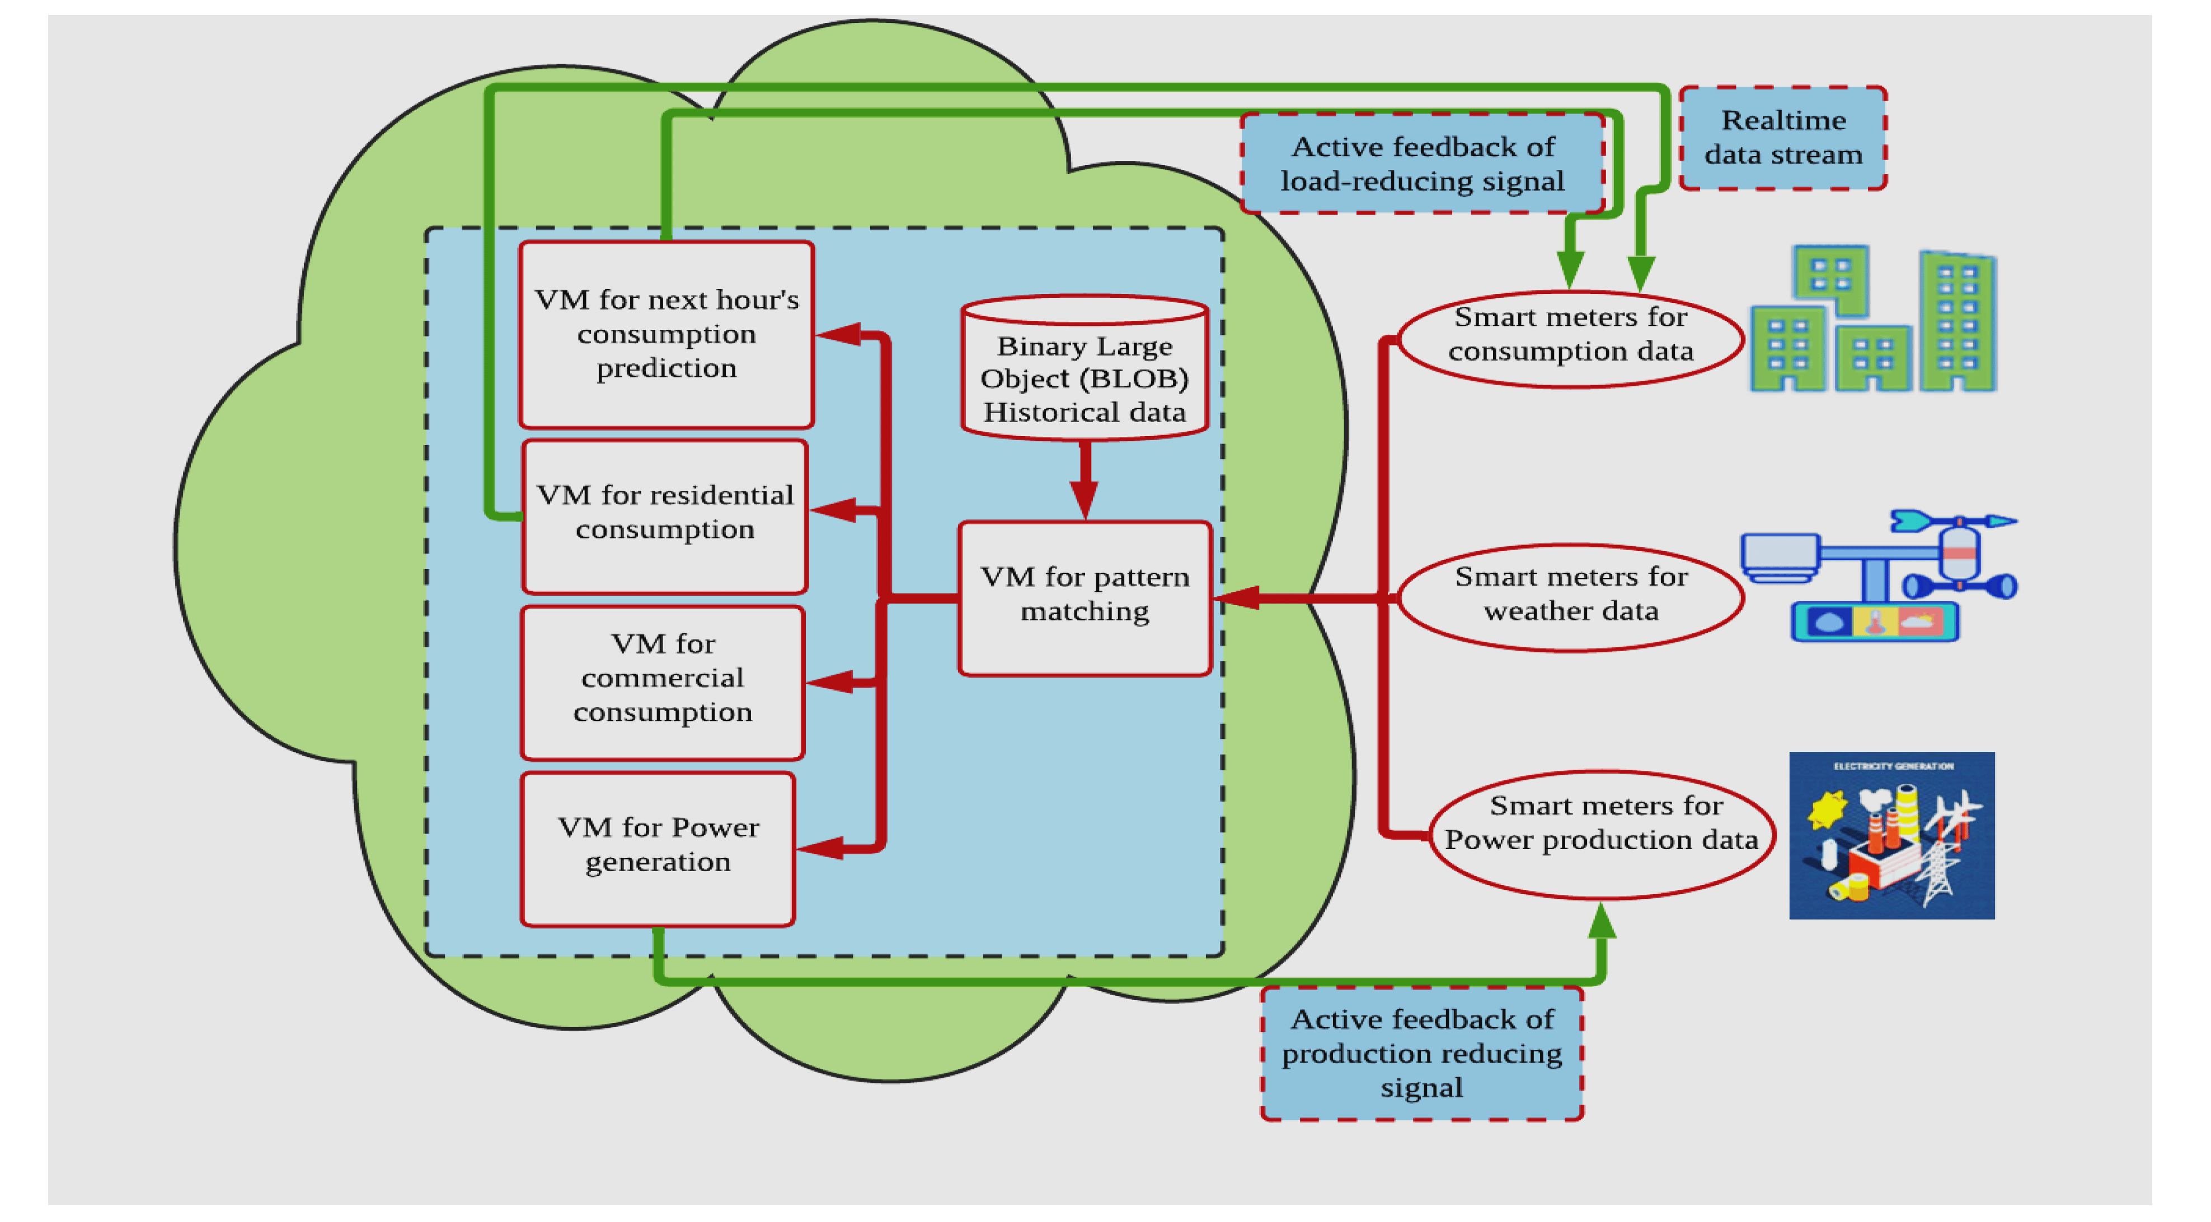

1. **Data Storage in the Cloud:**
   * The first step in big data analysis is storing the vast amounts of data in cloud-based storage solutions. Cloud providers like Amazon Web Services (AWS), Microsoft Azure, Google Cloud Platform (GCP), and IBM Cloud offer various storage options such as data lakes, object storage, and databases. Data can be ingested from various sources and stored in these repositories.
2. **Scalability and Elasticity:**
   * Cloud platforms provide the ability to scale your computational resources up or down as needed. This elasticity is crucial for handling large datasets and fluctuating workloads efficiently. It ensures that you can allocate resources for analysis when required and scale them down when not in use, helping to optimize costs.
3. **Data Processing and Analysis:**
   * Cloud platforms offer a wide range of data processing and analysis tools and services. These include distributed computing frameworks like Apache Hadoop and Spark, managed data processing services, and machine learning platforms. Users can choose the most appropriate tools for their specific analysis tasks.
4. **Managed Databases:**
   * Cloud providers offer managed database services that are highly scalable and suitable for big data applications. These databases can handle both structured and unstructured data. Examples include Amazon Redshift, Google BigQuery, and Azure SQL Data Warehouse.
5. **Data Integration and ETL:**
   * Cloud-based ETL (Extract, Transform, Load) tools allow users to easily integrate data from various sources, perform transformations, and load it into data warehouses or data lakes. These tools streamline the data preparation process for analysis.
6. **Serverless Computing:**
   * Serverless computing platforms, such as AWS Lambda, Azure Functions, and Google Cloud Functions, enable you to run code without provisioning or managing servers. This serverless architecture is useful for executing specific functions or tasks within your big data analysis pipeline.
7. **Data Visualization and Reporting:**
   * Cloud-based data visualization tools and services help users create interactive dashboards and reports to communicate insights effectively. Examples include Tableau Online, Power BI, and Google Data Studio.
8. **Machine Learning and AI Services:**
   * Cloud providers offer machine learning and artificial intelligence services that enable users to build, train, and deploy machine learning models at scale. These services simplify the implementation of advanced analytics within big data applications.
9. **Security and Compliance:**
   * Cloud providers invest heavily in security measures, and users can take advantage of built-in security features, encryption, and compliance certifications to protect sensitive data during analysis.
10. **Cost Management:**
    * Cloud services often come with cost management tools and features that help users track and optimize their spending on resources and services, making big data analysis more cost-effective.
11. **Global Availability and Accessibility:**
    * Cloud platforms have data centers worldwide, providing global accessibility and ensuring low-latency access to data and services from different geographic locations.

By leveraging cloud computing for big data analysis, organizations can harness the power of scalable resources and a wide range of tools and services to derive insights from large datasets while reducing the complexity and costs associated with managing on-premises infrastructure.

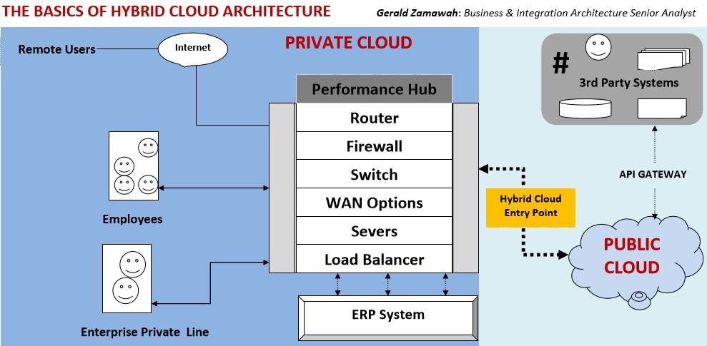 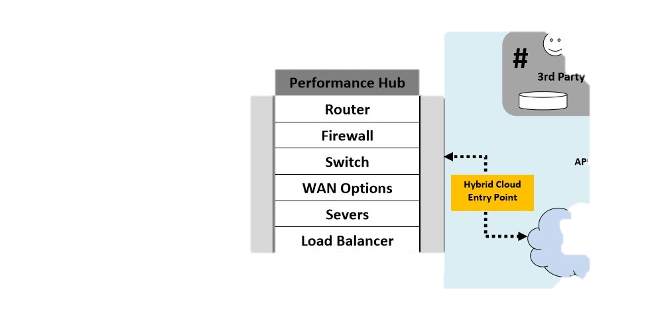Top of Form

